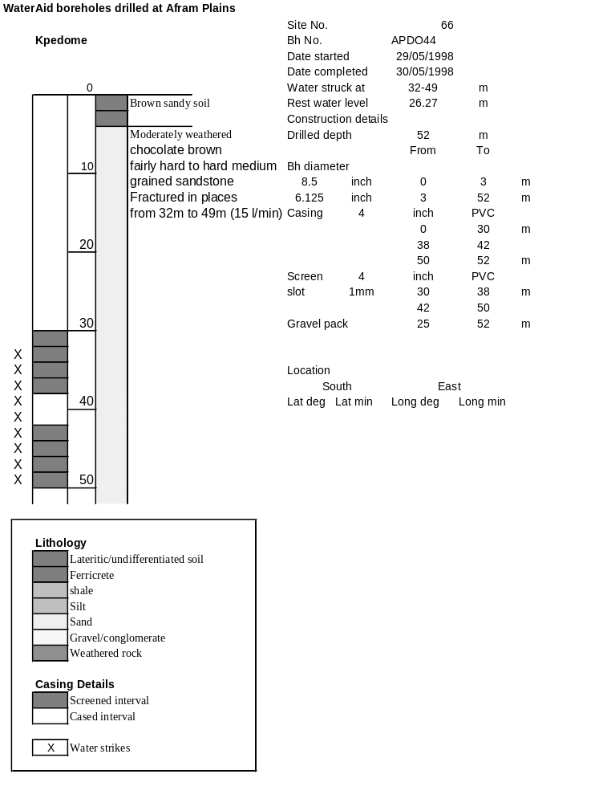

Ghana | Test pumping
Borehole No. |  | APDO44
Hole No |  | 66 | (16)
Village |  | Kpedome
Date |  | 17/11/1998
Point above GL |  | 0.5 | m
Pump depth |  | 40 | m
SWL |  | 26.77 | m
Start Time |  | 08:50
Drawdown test |  |  |  |  | Recovery Test
time | pwl (m) | Q l/min | dd | sc(q/s) | Time | wl (m) | t/t' | resdd
0.00 | 26.77 | 15.00 | 0.00 |  | 0.00 | 27.30 |  | 0.53
1.00 | 26.94 | 15.00 | 0.17 | 88.24 | 1.00 | 27.11 | 241.00 | 0.34
2.00 | 26.94 | 15.00 | 0.17 | 88.24 | 2.00 | 27.10 | 121.00 | 0.33
3.00 | 26.98 | 15.00 | 0.21 | 71.43 | 3.00 | 27.09 | 81.00 | 0.32
4.00 | 27.00 | 15.00 | 0.23 | 65.22 | 4.00 | 27.09 | 61.00 | 0.32
5.00 | 27.04 | 15.00 | 0.27 | 55.56 | 5.00 | 27.08 | 49.00 | 0.31
6.00 | 27.04 | 15.00 | 0.27 | 55.56 | 6.00 | 27.08 | 41.00 | 0.31
7.00 | 27.06 | 15.00 | 0.29 | 51.72 | 7.00 | 27.07 | 35.29 | 0.30
8.00 | 27.07 | 15.00 | 0.30 | 50.00 | 8.00 | 27.07 | 31.00 | 0.30
9.00 | 27.07 | 15.00 | 0.30 | 50.00 | 9.00 | 27.07 | 27.67 | 0.30
10.00 | 27.07 | 15.00 | 0.30 | 50.00 | 10.00 | 27.07 | 25.00 | 0.30
12.00 | 27.05 | 14.00 | 0.28 | 50.00 | 12.00 | 27.07 | 21.00 | 0.30
14.00 | 27.08 | 15.00 | 0.31 | 48.39 | 14.00 | 27.06 | 18.14 | 0.29
16.00 | 27.08 | 15.00 | 0.31 | 48.39 | 16.00 | 27.06 | 16.00 | 0.29
18.00 | 27.09 | 15.00 | 0.32 | 46.88 | 18.00 | 27.05 | 14.33 | 0.28
20.00 | 27.10 | 15.00 | 0.33 | 45.45 | 20.00 | 27.05 | 13.00 | 0.28
25.00 | 27.10 | 15.00 | 0.33 | 45.45 | 25.00 | 27.04 | 10.60 | 0.27
30.00 | 27.10 | 15.00 | 0.33 | 45.45 | 30.00 | 27.04 | 9.00 | 0.27
35.00 | 27.10 | 15.00 | 0.33 | 45.45 | 35.00 | 27.03 | 7.86 | 0.26
40.00 | 27.11 | 15.00 | 0.34 | 44.12 | 40.00 | 27.03 | 7.00 | 0.26
45.00 | 27.12 | 15.00 | 0.35 | 42.86 | 45.00 | 27.03 | 6.33 | 0.26
50.00 | 27.14 | 15.00 | 0.37 | 40.54 | 50.00 | 27.02 | 5.80 | 0.25
55.00 | 27.15 | 15.00 | 0.38 | 39.47 | 55.00 | 27.02 | 5.36 | 0.25
60.00 | 27.16 | 15.00 | 0.39 | 38.46 | 60.00 | 27.01 | 5.00 | 0.24
70.00 | 27.17 | 15.00 | 0.40 | 37.50 | 70.00 | 27.00 | 4.43 | 0.23
80.00 | 27.17 | 15.00 | 0.40 | 37.50 | 80.00 | 26.99 | 4.00 | 0.22
90.00 | 27.18 | 15.00 | 0.41 | 36.59 | 90.00 | 26.99 | 3.67 | 0.22
100.00 | 27.19 | 15.00 | 0.42 | 35.71 | 100.00 | 26.98 | 3.40 | 0.21
110.00 | 27.20 | 15.00 | 0.43 | 34.88 | 110.00 | 26.97 | 3.18 | 0.20
120.00 | 27.21 | 15.00 | 0.44 | 34.09 | 120.00 | 26.96 | 3.00 | 0.19
130.00 | 27.22 | 15.00 | 0.45 | 33.33
140.00 | 27.23 | 15.00 | 0.46 | 32.61
150.00 | 27.24 | 15.00 | 0.47 | 31.91
160.00 | 27.25 | 15.00 | 0.48 | 31.25
170.00 | 27.25 | 15.00 | 0.48 | 31.25
180.00 | 27.27 | 15.00 | 0.50 | 30.00
190.00 | 27.27 | 15.00 | 0.50 | 30.00
200.00 | 27.28 | 15.00 | 0.51 | 29.41
210.00 | 27.28 | 15.00 | 0.51 | 29.41
220.00 | 27.29 | 15.00 | 0.52 | 28.85
230.00 | 27.29 | 15.00 | 0.52 | 28.85
240.00 | 27.30 | 15.00 | 0.53 | 28.30

